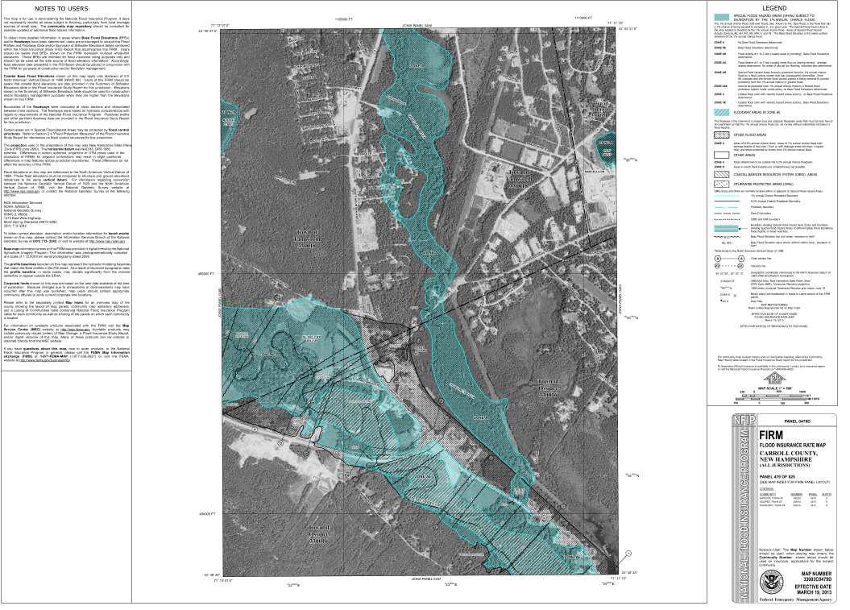FEMA map number 33003C0479D

Property is partially located within 100 year floodplain